BaaN | Bezeichnung SAP  Materialnummer SAP |  | Barcode
P002 |  | 84068726 | Pallet_WOi_800x600  Halbe Palette
P088 | Pallet with middleboard IPPC 800x710x122 | 92000321 | 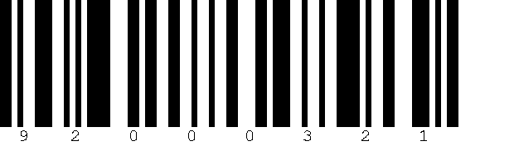
P056 |  | 84096500 | Pallet_WOi_1430x8004 x 710er auf Palette
P099 | Pallet_WOi_1200x800_EPAL  Europalette | 84096501 | 
B001 | 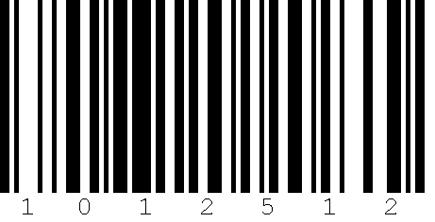 | 1012512 | Box_CA_1200x800x850_BN_PET  Eurotainer
B002 | Box_CA_800x600x600_BN_PETS  Eurobox | 1013483 | 
K039 |  | 84149232/ | Box_CA_381x  281x246mm
K001 | Box_CA_180x180x  260_BN_L101 | 1010524 | 
KI00 |  | 84142629 | Box_PWi_1200x  800x1050_BN_PNB  Seekiste gross
013 | Reel_WOi_900x  450x550  900er Spule stehend | 84150858 | 
014 |  | 84142621 | Reel_WOi_1050x  550x700  1050er Sp. stehend
015 | Reel_WOi_1250x  700x730  1250er Sp. stehend | 84142615 | 
BaaN | Bezeichnung SAP  Materialnummer SAP |  | Barcode
K003 |  | 1013014 | Box_CA_400x400x  270_BN_L103
K004 | Box_CA_480x260x  390_BN_L104 | 1012229 | 
K006 |  | 84149236 | Box_CA_450x  250x450mm
KI07 | Box_PWi_1200x  800x630_BN_PNM  Seekiste halb | 84142628 | 
KI33 |  | 84142630 | Box_PWi_800x  600x600_BN_PNS  Seekiste klein
KI44 | P-VIKEX-Box 460x460x410mm  Seekiste ganz klein | 92000340 | 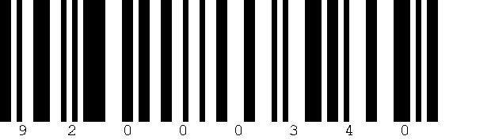
T001 | 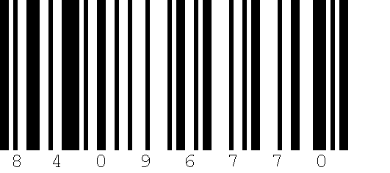 | 92000384 | Bag_PL_37x  29_T001
P450 | Europalette überbreit L450 oder L500  120 x 84 x (X) | 92000383 | 
P900 |  | 92000380 | Pallet with Reel 910  120x90x103
P105 | Pallet with Reel 1050  120x105x118 | 92000381 | 
P125 |  | 92000382 | Pallet with Reel 1250  120x125x138
K059 | Karton 26x26x20 | 84149235 / 92000341 | 
P001 |  | 84142626 | 710er stehend Bosch Palette

